**Assignment 2: Produce a comparative infographic of TDD, BDD, and FDD methodologies. Illustrate their unique approaches, benefits, and suitability for different software development contexts. Use visuals to enhance understanding.**

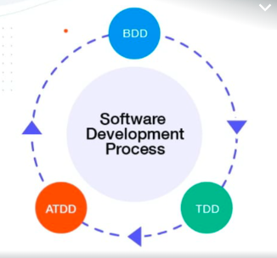

**- *TDD (Test-Driven Development):**

- *Approach: Focuses on writing tests before code.

- *Benefits: Reduces rework time, explores bugs quickly, enhances productivity.

- *Suitability: Ensures code correctness and cleaner designs.

**- *BDD (Behaviour-Driven Development):**

- *Approach: Defines system behaviour through testing.

- *Benefits: Promotes collaboration, reduces misunderstandings.

- *Suitability: Emphasizes understanding requirements and acceptance tests.

**- *FDD (Feature-Driven Development):**

- *Approach: * Centres around feature-centric development.

- *Benefits: Breaks down the system into manageable features, iterative development.

- *Suitability: Focuses on high-level design models and feature implementation.